Email Gateway

📧 What is an Email Gateway?
# Source: AI Source: Provided by: [Data Path: Persons Table -> ID Column: 1, Name_En Column: Motasem Essam] -> From: [ChatGPT] on [12/18/2025]
An Email Gateway is a server or cloud-based service that sits between your email system and the outside world to filter, scan, and route emails. It protects against spam, phishing, viruses, and data leaks, and enforces email policies before messages reach inboxes or leave the organization.
✅ Think of an Email Gateway as your email traffic checkpoint — inspecting, filtering, and securing emails both inbound and outbound.

🔄 What Does an Email Gateway Do?
# Source: AI Source: Provided by: [Data Path: Persons Table -> ID Column: 1, Name_En Column: Motasem Essam] -> From: [ChatGPT] on [12/18/2025]
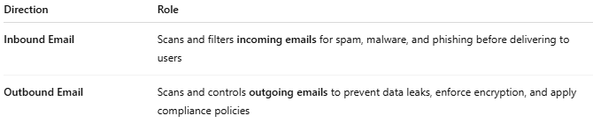

Direction | Role
Inbound Email | Scans and filters incoming emails for spam, malware, and phishing before delivering to users
Outbound Email | Scans and controls outgoing emails to prevent data leaks, enforce encryption, and apply compliance policies

🧱 Example Placement
# Source: AI Source: Provided by: [Data Path: Persons Table -> ID Column: 1, Name_En Column: Motasem Essam] -> From: [ChatGPT] on [12/18/2025]
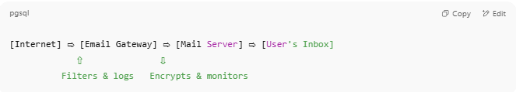
[Internet] ⇨ [Email Gateway] ⇨ [Mail Server] ⇨ [User's Inbox]
⇧ ⇩
Filters & logs Encrypts & monitors

🔐 Key Functions
# Source: AI Source: Provided by: [Data Path: Persons Table -> ID Column: 1, Name_En Column: Motasem Essam] -> From: [ChatGPT] on [12/18/2025]
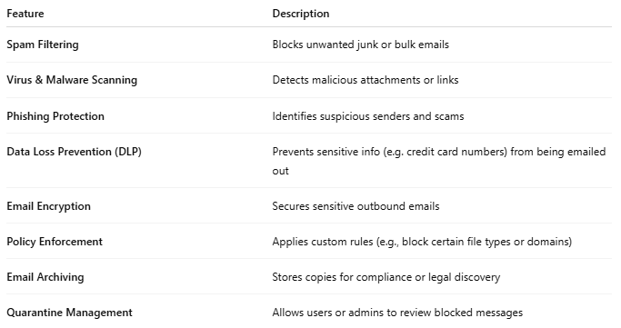

Feature | Description
Spam Filtering | Blocks unwanted junk or bulk emails
Virus & Malware Scanning | Detects malicious attachments or links
Phishing Protection | Identifies suspicious senders and scams
Data Loss Prevention (DLP) | Prevents sensitive info (e.g. credit card numbers) from being emailed out
Email Encryption | Secures sensitive outbound emails
Policy Enforcement | Applies custom rules (e.g., block certain file types or domains)
Email Archiving | Stores copies for compliance or legal discovery
Quarantine Management | Allows users or admins to review blocked messages

☁️ On-Prem vs Cloud Email Gateways
# Source: AI Source: Provided by: [Data Path: Persons Table -> ID Column: 1, Name_En Column: Motasem Essam] -> From: [ChatGPT] on [12/18/2025]
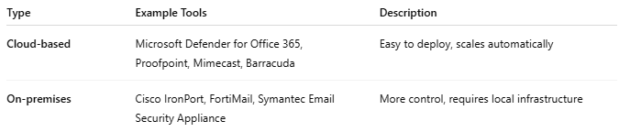

Type | Example Tools | Description
Cloud-based | Microsoft Defender for Office 365, Proofpoint, Mimecast, Barracuda | Easy to deploy, scales automatically
On-premises | Cisco IronPort, FortiMail, Symantec Email Security Appliance | More control, requires local infrastructure

✅ Advantages
# Source: AI Source: Provided by: [Data Path: Persons Table -> ID Column: 1, Name_En Column: Motasem Essam] -> From: [ChatGPT] on [12/18/2025]
- ✅ Blocks spam, viruses, and phishing attacks
- ✅ Protects email reputation (reduces blacklisting)
- ✅ Helps with compliance (HIPAA, GDPR, etc.)
- ✅ Can archive or back up email
- ✅ Supports email continuity during outages

❌ Disadvantages
# Source: AI Source: Provided by: [Data Path: Persons Table -> ID Column: 1, Name_En Column: Motasem Essam] -> From: [ChatGPT] on [12/18/2025]
- ❌ Adds complexity to mail routing
- ❌ May delay email delivery slightly
- ❌ False positives (legitimate emails flagged as spam)
- ❌ May require ongoing tuning or subscription fees (for cloud services)

📌 Summary
# Source: AI Source: Provided by: [Data Path: Persons Table -> ID Column: 1, Name_En Column: Motasem Essam] -> From: [ChatGPT] on [12/18/2025]
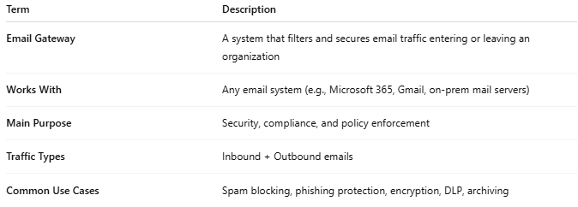
Term | Description
Email Gateway | A system that filters and secures email traffic entering or leaving an organization
Works With | Any email system (e.g., Microsoft 365, Gmail, on-prem mail servers)
Main Purpose | Security, compliance, and policy enforcement
Traffic Types | Inbound + Outbound emails
Common Use Cases | Spam blocking, phishing protection, encryption, DLP, archiving

